Assignment 10

Name – Abhishek Agrahari

Roll Number 190123066

Question 1

First 25 values of the Van der Corput sequence using the radical inverse function are –

[0.5, 0.25, 0.75, 0.125, 0.625, 0.375, 0.875, 0.0625, 0.5625, 0.3125, 0.8125, 0.1875, 0.6875, 0.4375, 0.9375, 0.03125, 0.53125, 0.28125, 0.78125, 0.15625, 0.65625, 0.40625, 0.90625, 0.09375, 0.59375]

Plot of overlapping pairs (Xi, Xi+1) for first 1000 numbers from Van der Corput sequence.

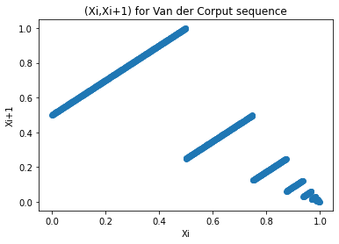

Xi+1 is mostly linearly dependent on Xi with few breakpoints.

Question 2

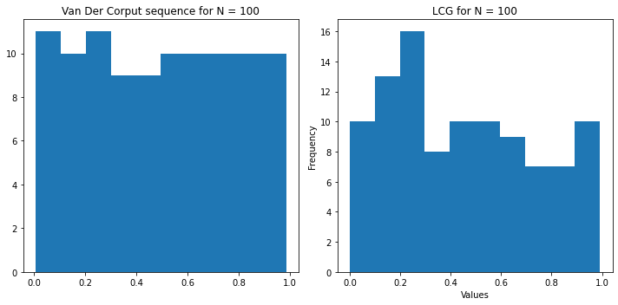

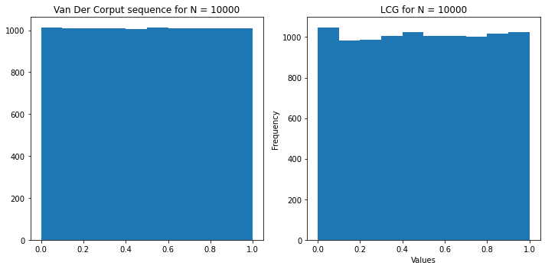

Both for N = 100 and N = 100000, Van der Corput have generated numbers that are more uniformly distributed as compared to LCG.

I have used the following formula for generating from LCG -

Xi+1 = (a\*Xi + c) % m

Ui+1 = Xi+1/m

where I have taken a = 2057, c = 1345, m = 250, and X0 = 3245

Question 3

Generated and plotted first 100 and 100000 values from the Halton sequence Xi = (.

where $ϕ_{b}\left(i\right)= \sum_{k=0}^{∞}{d_{k}b^{-k-1}}$

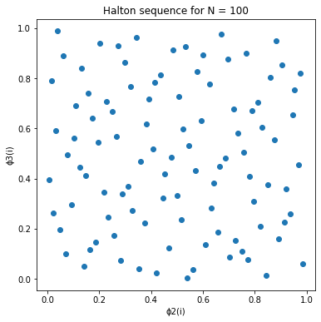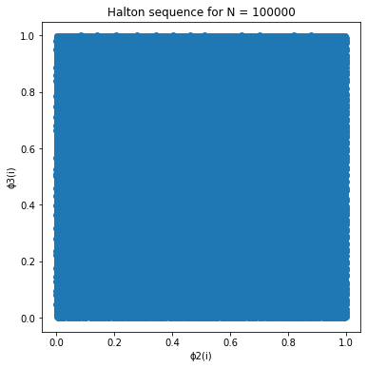

In both the cases points are uniformly distributed in [0,1]2.